Equity and Antiracism Planning Council (EAPC) Pilot
Agenda & DRAFT Notes
March 21, 2023 2:10-4:00pm CANCELED due to power outage
April 11 2023, 2:10 - 4:00 pm
Join Zoom Meeting: https://smccd.zoom.us/j/88028752948
MISSION: The mission of the Equity and Antiracism Planning Council is to disrupt and dismantle systemic racism and White supremacy for our college community in pursuit of equity, antiracism, justice and liberation.

VOTING MEMBERS (18):

Tri-chairs (3):
· Staff – Krystal Martinez
· Faculty – Alison Field
· Administrator – Wissem Bennani
Faculty (5):
· English/Math – Yolanda Valenzuela
· ESL – Rebekah Taveau
· Counseling – Chris Rico
· At large – Leonor Cabrera
· At large – Eddy Harris
Classified (6):
· Gonzalo Arrizon
· Rance Bobo
· Michiko Kealoha
· Alyssa Lucchini
· Krystal Martinez
· Mahitha Rao
ASCC (2):
· Yuliana Leon Subias
· Noah Liu
PRIE (1):
· Karen Engel
Admin (1):
· Kathleen Sullivan-Torrez

In Attendance:

2:10 pm  5 mins | Welcome  - Notetaker:  - Time Keeper:  Approval of Agenda:  Karen moved to approve the EAPC agenda for April 11, 2023. Seconded by Noah. Motion passes unanimously by the consent of those present.  Approval of Feb. 28 Notes  Karen moved to approve the EAPC minutes for February 28, 2023. Seconded by Mahita. Motion passes unanimously by the consent of those present. | Alison  Action
2:15 pm  5 mins | EAPC Leadership updates  - Tri-chair appointment  - Director of Equity job announcement & timeline  - Faculty Equity Coordinator (2023-2025)  We have our staff tri-chair! Congratulations to Krystal!! And thank you Michiko and Krystal for both volunteering for this role.  Alison will be completing her term for faculty coordinator and there have been a few applications. Those are being reviewed and will go to the VPI. A decision should be made fairly soon. More news to come!  The Director of Equity hiring committee just closed April 10. They should be meeting this week, if you are interested in being a part of the hiring committee, please let Alison or Dave Eck know. That is happening this Thursday. The Chair is Dr. Wissem Bennani for this. Should be hearing back from Classified Senate shortly. | Alison  Info.
2:20 pm  50 mins | EAPC Orientation, Part II  - “Talking about Race Topic: Being Antiracist” (National Museum of African American History and Culture).  Nimsi shares information:  Arao, B., Clemens, K. (2013) safe vs. brave spaces. Community agreements can be counter productive to fostering conversations about racism. Safety as a concept for all involved leave some participants left out. It can also continue the cycle of White Supremacy. In order to have critical conversations, we need to lean into discomfort. Safe Zone team rebranded to Brave Space collective to have more of an equity and anti-racist lens. We are doing a flex day presentation about this!  Controversy with civility, Own your intensions and your impact, challenge by choice  We then went over the 5 senses and what we think Brave Spaces feels, smells, taste, hears, looks like.  Alison shares about the survey results of EAPC. We are comfortable with definitions.  There are some people that are neutral on participatory governance and want to learn more about CRT and Liberation theory.  Mary talks about our reading and that we will be broken up into groups and discuss the following:  - What are some initial reactions to Being Antiracist article? Anything that resonated with you?  - How has racism, racist ideas and/or policies manifest in these ways: at an individual level, an institutional level, a systemic level?  Closing question: was there anything uncomfortable about this exercise?  People discuss spending a lot of time on the first question and then not having time for the second question. Other people discuss the level of exposing the level of uncomfortability. People shared how they are more protective of their experiences and would rather disengage regarding overt racism. In order to invoke a Brave Space a lot of it is getting to know each other, and trust. People continue to share their personal experiences surrounding bias and racism.  EAPC Anti-Racism & Equity Goals  Note: Preview for next meeting April 25:  - SEAP plan presentation (Fall 22)  - Cañada’s SEAP Plan  Krystal will assign reading and we’ll decide what goals we would like to be a part of. | Nimsi, Mary & Alison  Discussion  Krystal
3:10 pm  15 mins | Updating the Compendium of Committees and Participatory Governance Manual  - Review draft document & gather input: Proposed changes to the Compendium of Committees  (For reference - our draft illustration of EAPC’s “wrap-around” approach or “hug”: presentation to PBC, May 2022)  Karen shares screen and discusses the difference between councils, Senates, Task Forces, and Operational Groups.  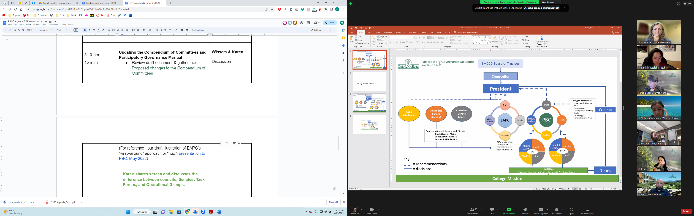  How do we best show the “hug”? (The collaboration aspect of EAPC) | Wissem & Karen  Discussion
3:25 pm  5 mins | Call for participation: “EAPC Open House” & “EAPC Updates”  - April 20 Flex Session: “EAPC Open House”  - “EAPC Updates” (SSPC, IPC, ASCC, Academic and Classified Senates)  Is anyone able to volunteer at EAPC Flex open house? 1-2pm  Michiko, Mary, Maria H., Mahita (TBD), Yolanda (TBD) will be there! | Krystal
3:30 pm  25 mins | EAPC Technical Operations:  - Tri-chairs recommendation to onboard pre-existing ACES sub-committee & Task Force  - Dreamers Task Force (subcommittee)  Noticed that not many of AB540 or DACA students were familiar with the process or hoping to get financial aid. It started around advocacy and sharing information and resources around financial aid. It evolved around advocating to have more resources for Dream Center and Staffing and Undocumented Student Week of Action. It’s been chaired or co-chaired by the Dream Center staff member and it’s gone through a lot of different iterations.  - Task Force on Land Acknowledgements & Beyond (TF)  Fall 2022 and how Student Senate asked ACES to start a Task Force inquiry group about acknowledging the land and who the land belongs to.  ***Karen makes a note that “perhaps we could rename each of these groups from being "task forces" to being "operational groups"? Or subcommittees? According to our participatory governance manual, a task force is, by definition, created for a short time (less than a year) for a specific task. And these groups may be on-going…”  Krystal moves to adopt the Tri-chairs recommendation to onboard pre-existing ACES sub-committee & Task Force: specifically the Dreamers Task Force and Task Force on Land Acknowledgements & Beyond, with updating these bodies titles by the end of the Spring 2023. Seconded by Gonzalo. Motion approved unanimously by the consent of those present.  - Integration of sub-committees & Task Forces as part of the EAPC  - Regular meeting updates/reports  - Past practice in ACES:  - Dreamers  - Guided Pathways  - Cultural Center  - District Antiracism TF  - UMOJA  - ASCC  - Task Force on Land Ackn  - EAPC spring schedule updates  - May meeting: 1 hour  - (May 16 or 23)  - June retreat:  - Thurs. June 22? | Wissem  Action  Discussion
3:55 pm  5 mins | Announcements / Good of the Order  Would like to have a May 16 meeting. | (Please post in the Chat)
4:00 pm | Adjourn  · Next meeting: April 25  Krystal calls to adjourn at 4:01 pm!

